**//FAISAL RASOOL QAZI**

**//ROLL NO: 455689**

**//LAB MANUALS-07**

**//TASK 01**

#include<iostream>

using namespace std;

int main(){

int x[10];

cout<<"Enter the integers: "<<endl;

for(int i=0;i<10;i++){

cin>>x[i];

}

cout<<"The seqeunce is: ";

for(int i=0;i<10;i++){

cout<<x[i]<<" ";

}

return 0;

}

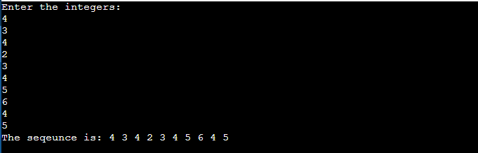

**//TASK 02**

#include <iostream>

using namespace std;

int main() {

const int n=5;

int arr[n];

cout<<"Enter "<<n<<"integers :"<<endl;

for (int i=0; i<n; ++i) {

cin>>arr[i];

}

int sum =0;

long long product =1;

for (int i=0; i<n; ++i) {

sum= sum + arr[i];

product= product * arr[i];

}

cout<<"Sum of the integers :"<<sum<<endl;

cout<<"Product of integers :"<<product<<endl;

return 0;

}

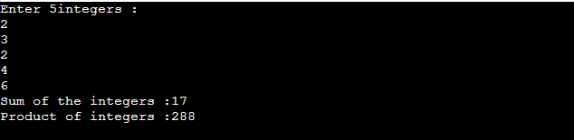

**//TASK 03**

#include <iostream>

using namespace std;

int main()

{

int row,space;

cout<<"Enter the number of rows: ";

cin>>row;

space=row-1;

for(int k=1;k<=row;k++)

{

for(int c=1;c<=space;c++)

{

cout<<" ";

}

space--;

for(int c=1;c<=2*k-1;c++)

{

cout<<"*";

}

cout<<"\n";

}

space=1;

for(int k=1;k<=row-1;k++)

{

for (int c=1;c<=space;c++)

{

cout<<" ";

}

space++;

for (int c=1 ;c<=2*(row-k)-1;c++)

{

cout<<"*";

}

cout<<"\n";

}

return 0;

}

